SFMC: Fire an event API
Fire an Event API from AJO to SFMC. It allows an external event to post an event to SFMC
End point: POST /interaction/v1/events
Key Use: Starts a journey in SFMC programmatically.
Advantages:
- If SFMC already has a built journey with heavy personalization, multiple branches or AMPscript content, you don’t need to rebuild it to AJO
- Multi Channel journey – If SFMC is managing email, sfmc or any other channel. Then such multi channel journey can be triggered from AJO

Designed for: 1 to 1 triggering (ingesting a single contact per API call). Each API request carries one Contact key(plus attributes) -> injected into journey builder. So best suited for real time, event based triggers.
High level flow:
AJO -> Custom Action -> Journey – Fire event API -> SFMC event entry -> contact injected -> Journey executes.

Ref, https://developer.salesforce.com/docs/marketing/marketing-cloud/references/mc_rest_interaction/postEvent.html
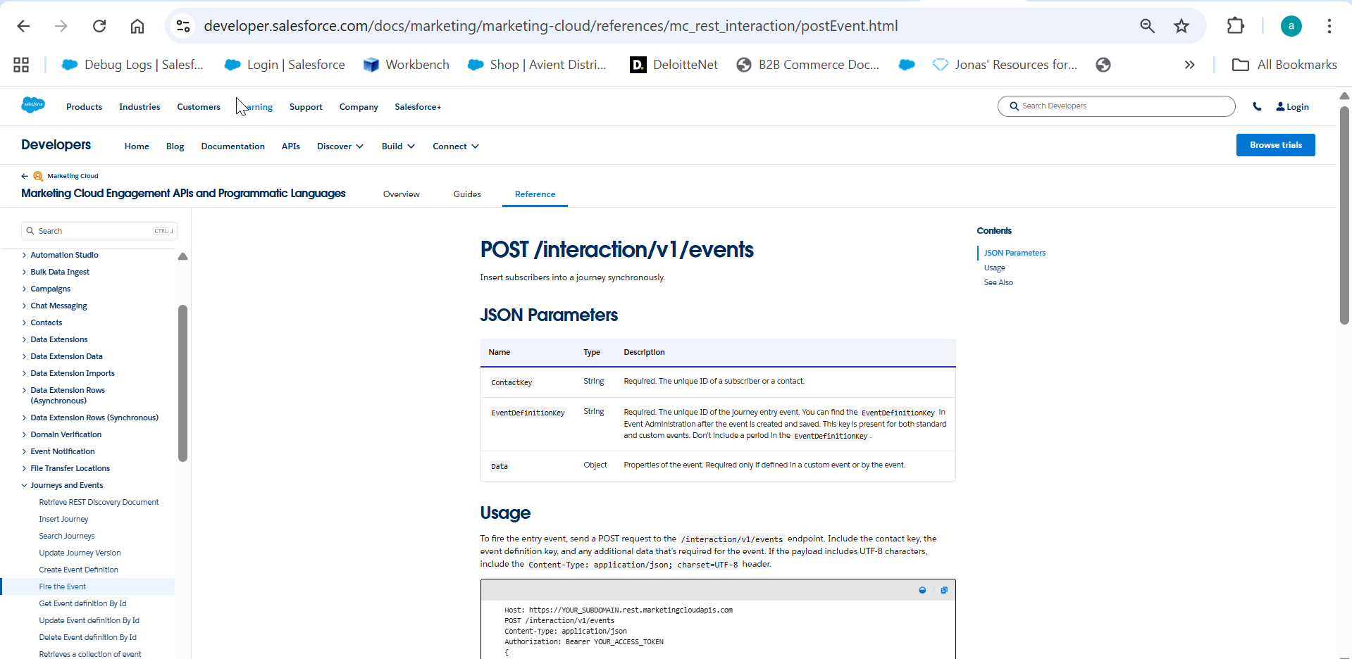

SFMC steps:

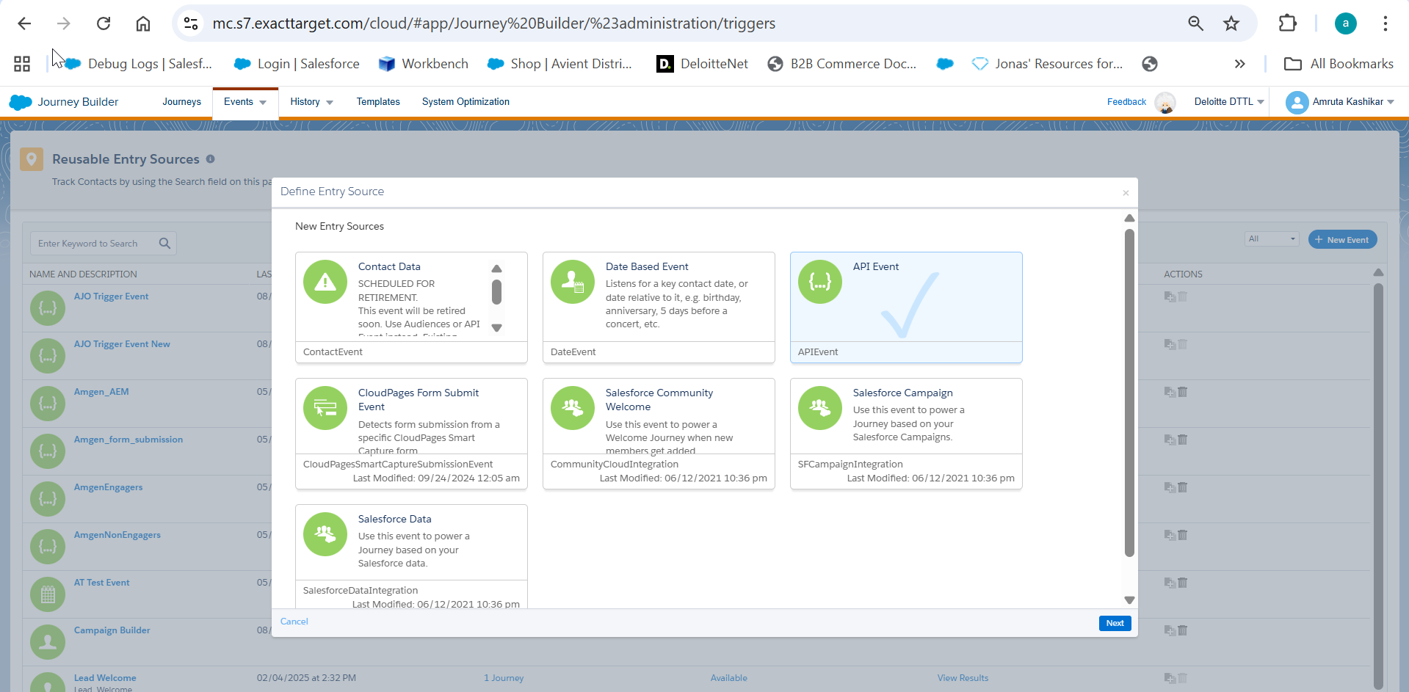

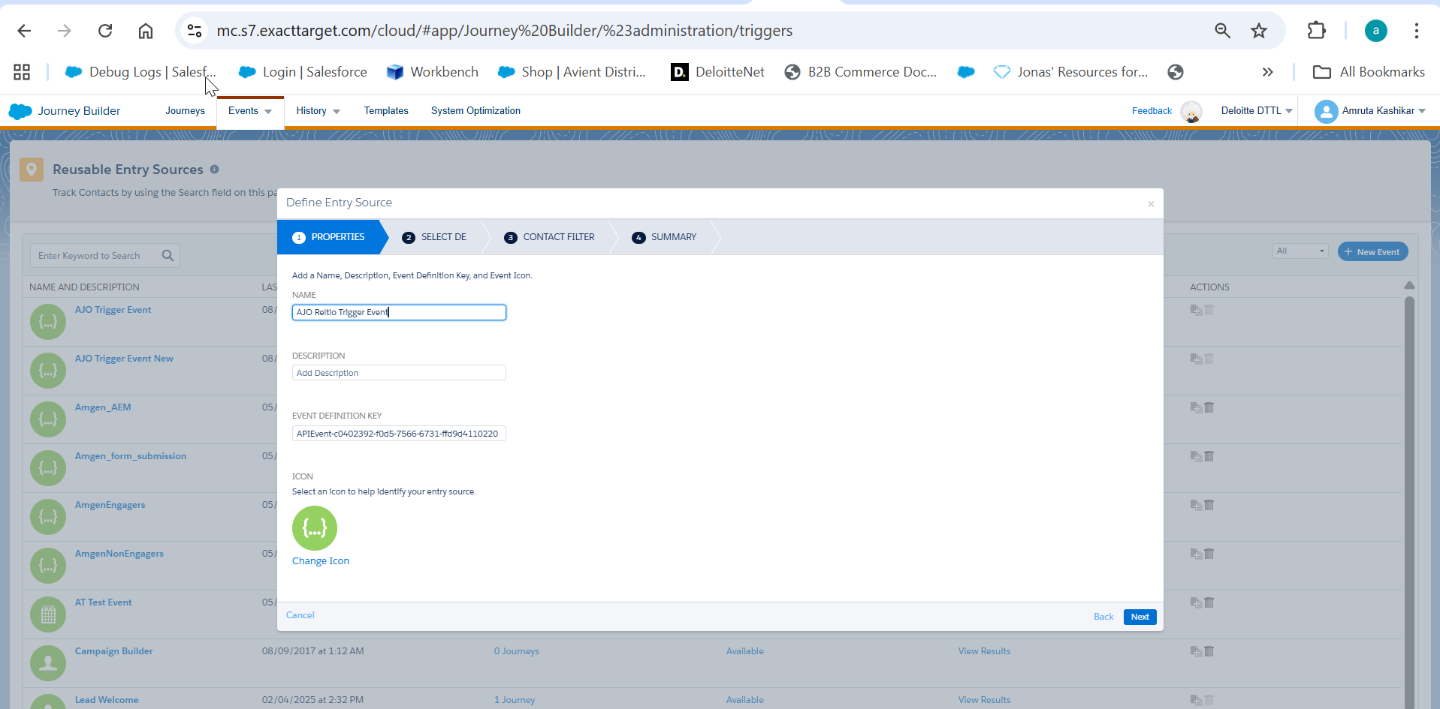

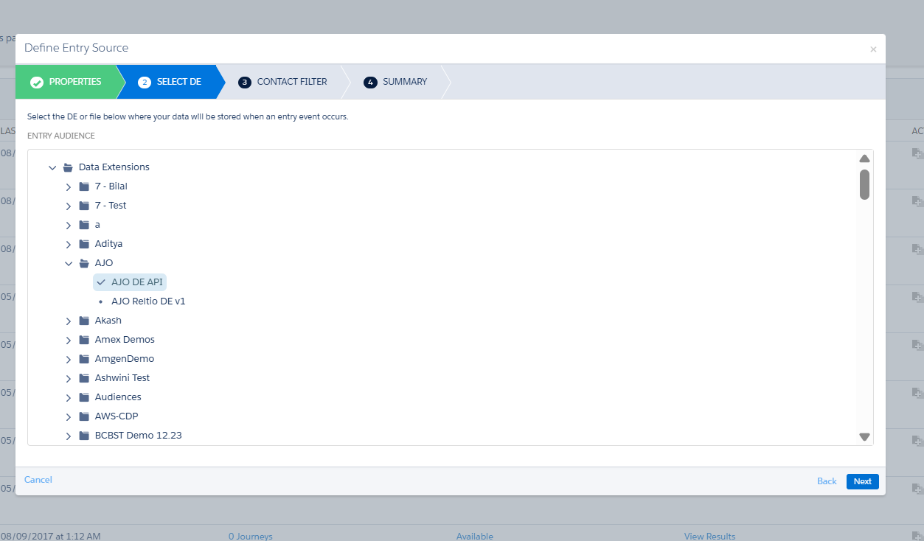

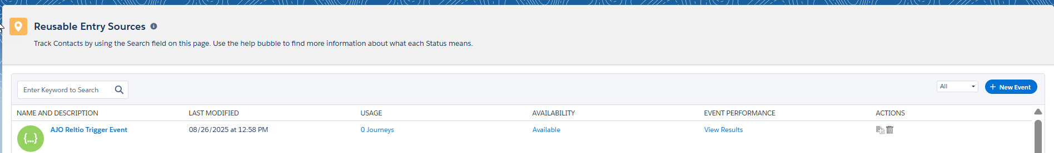

Create A Journey

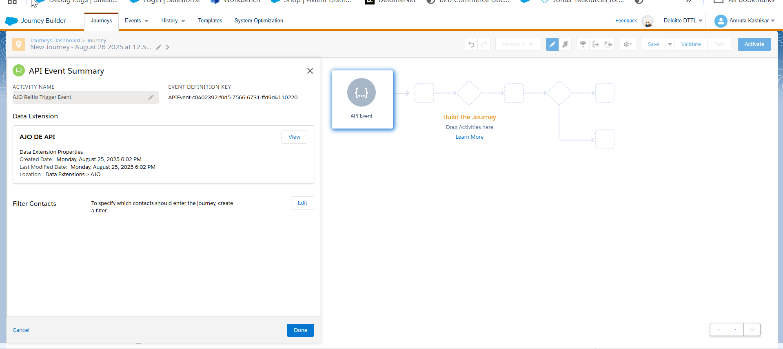

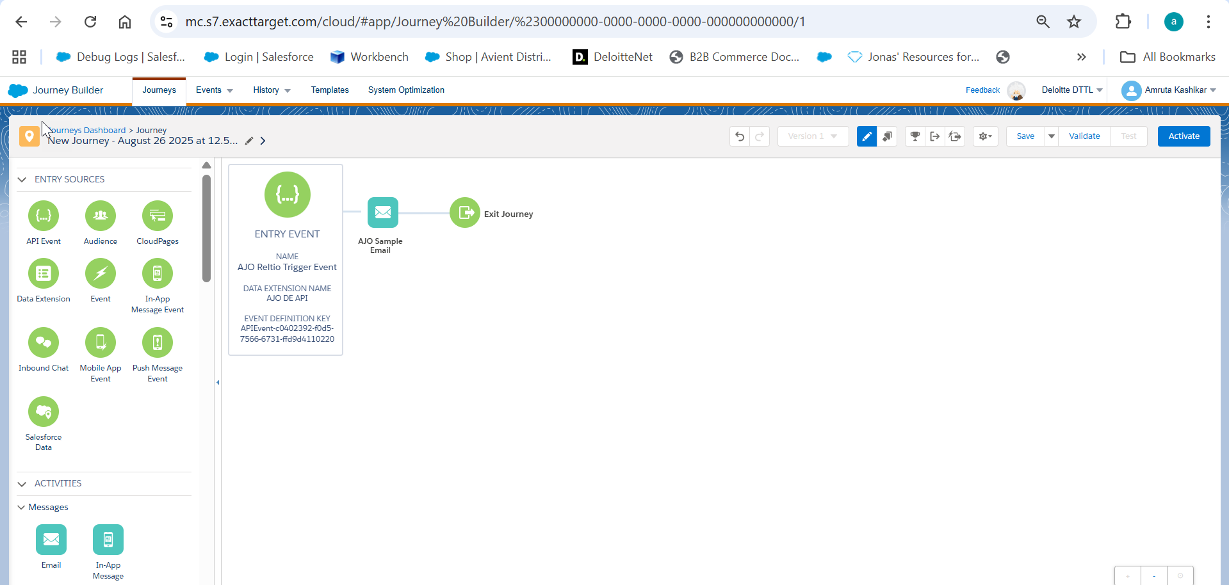

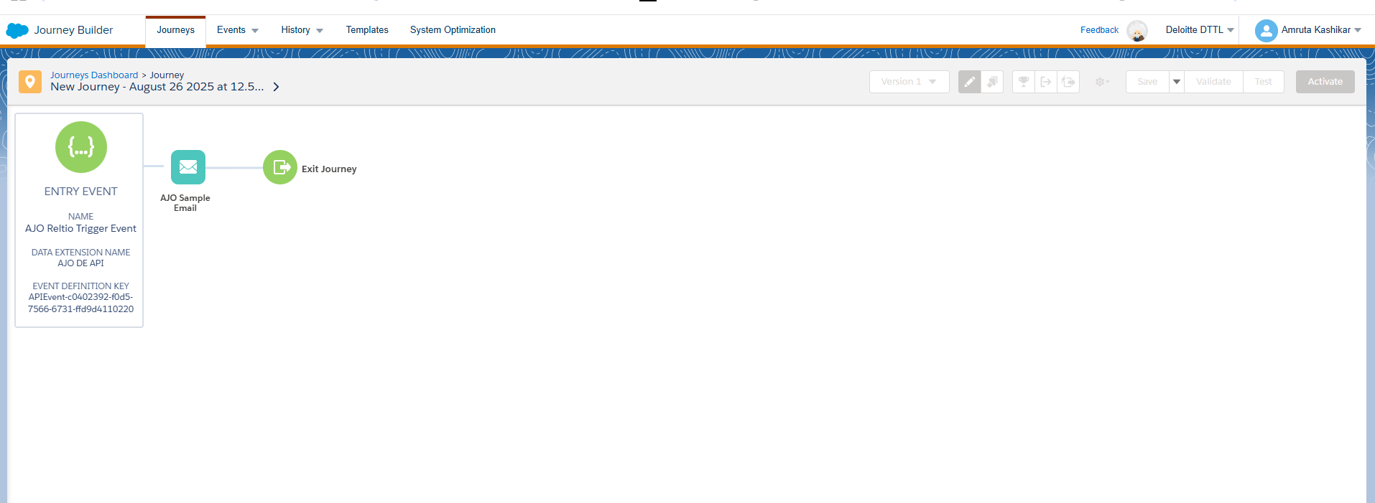

Postman test:

{
"ContactKey": "ReltioFIREEVENT1",
"EventDefinitionKey":"APIEvent-c0402392-f0d5-7566-6731-ffd9d4110220",
"Data": {
"Reltioid":"ReltioFIREEVENT1",
"Reltio Email Address":"akashikar1@deloitte.com"
}
}
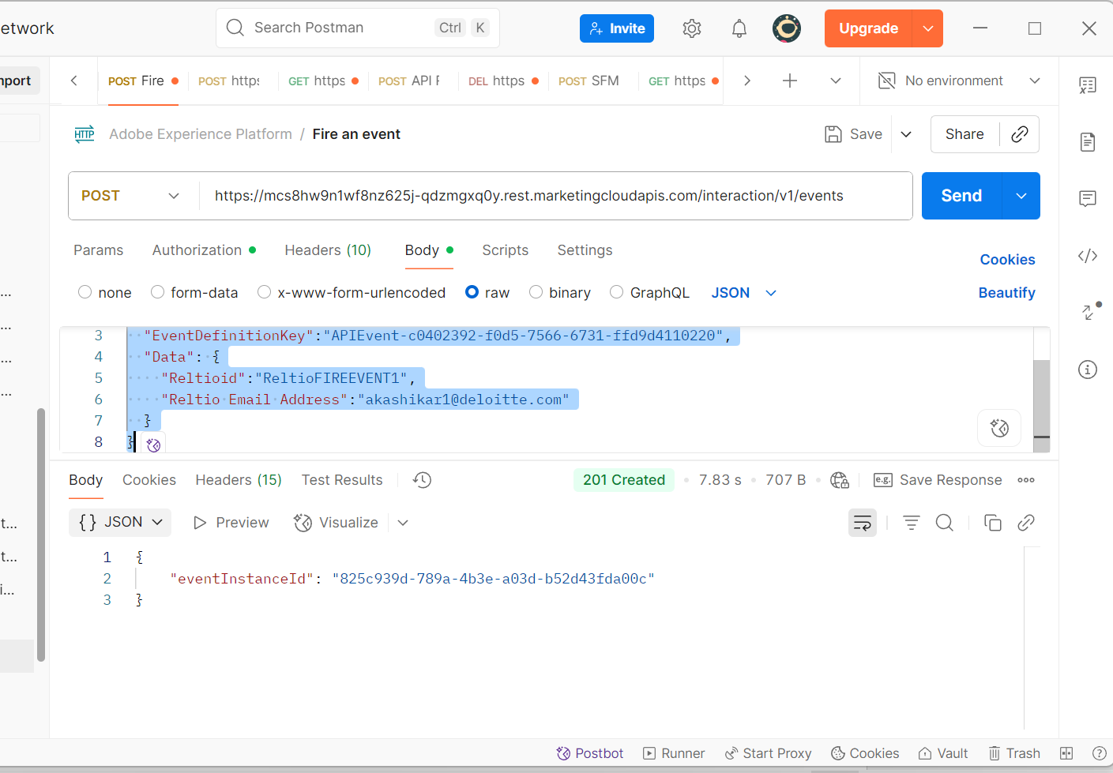

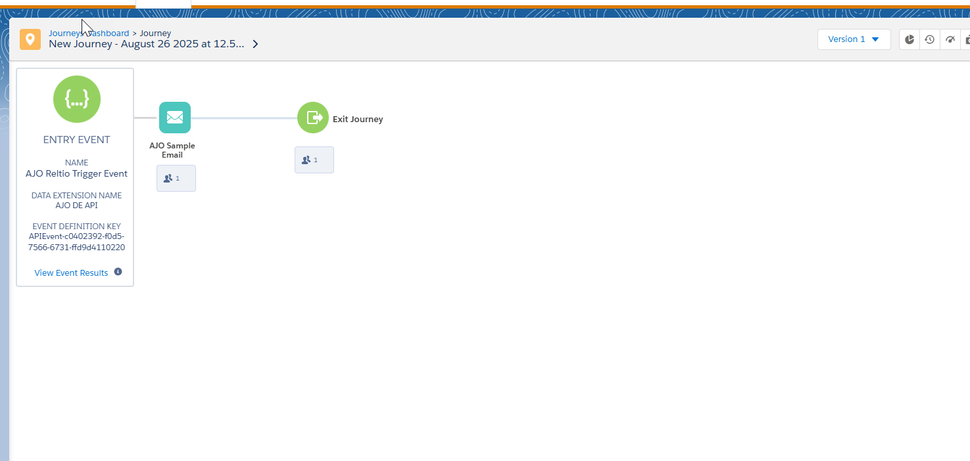

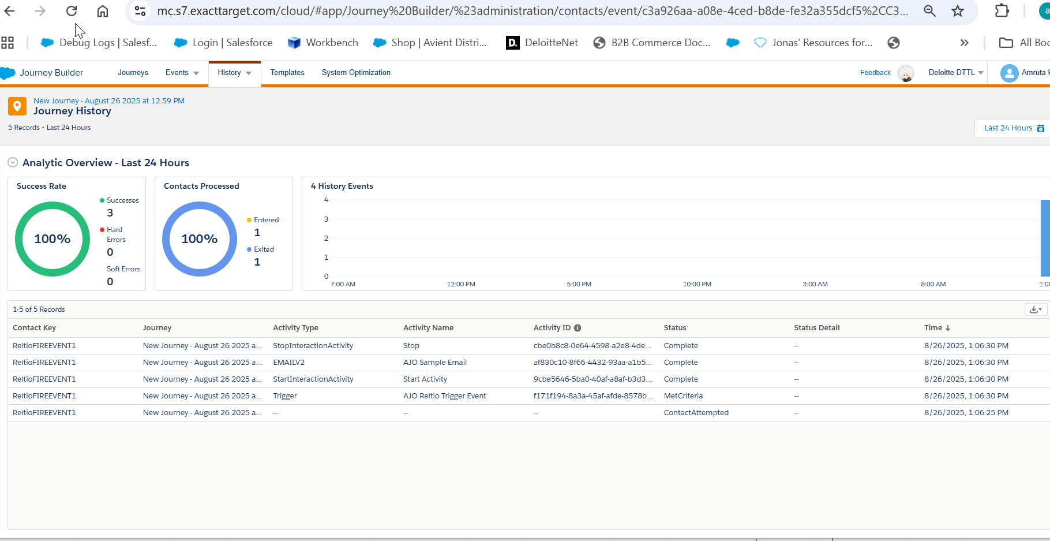

Now trying though Action in AJO

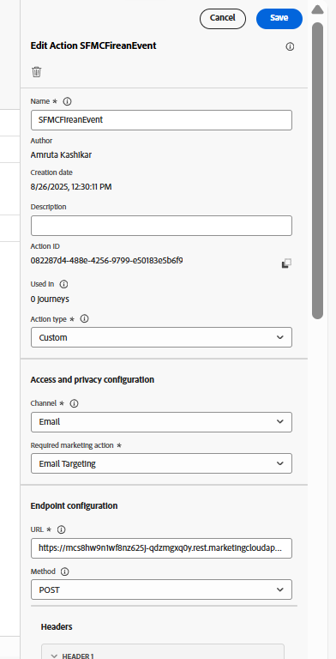

Auth payload
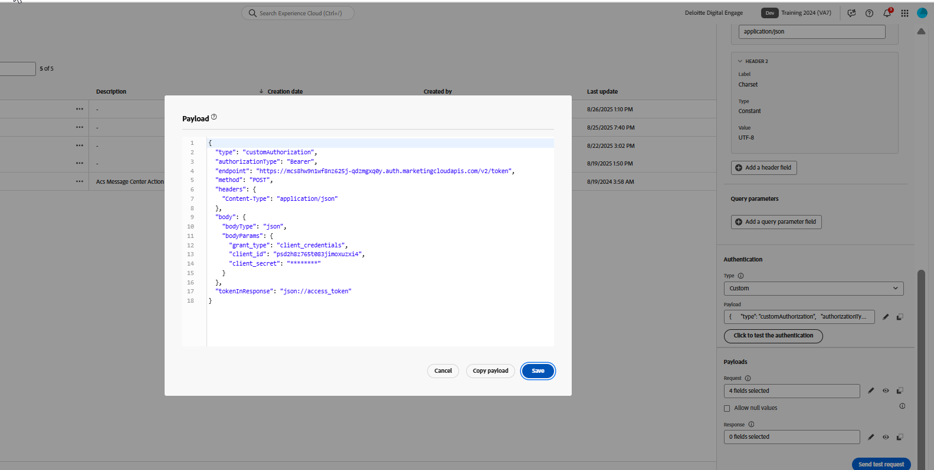

Body
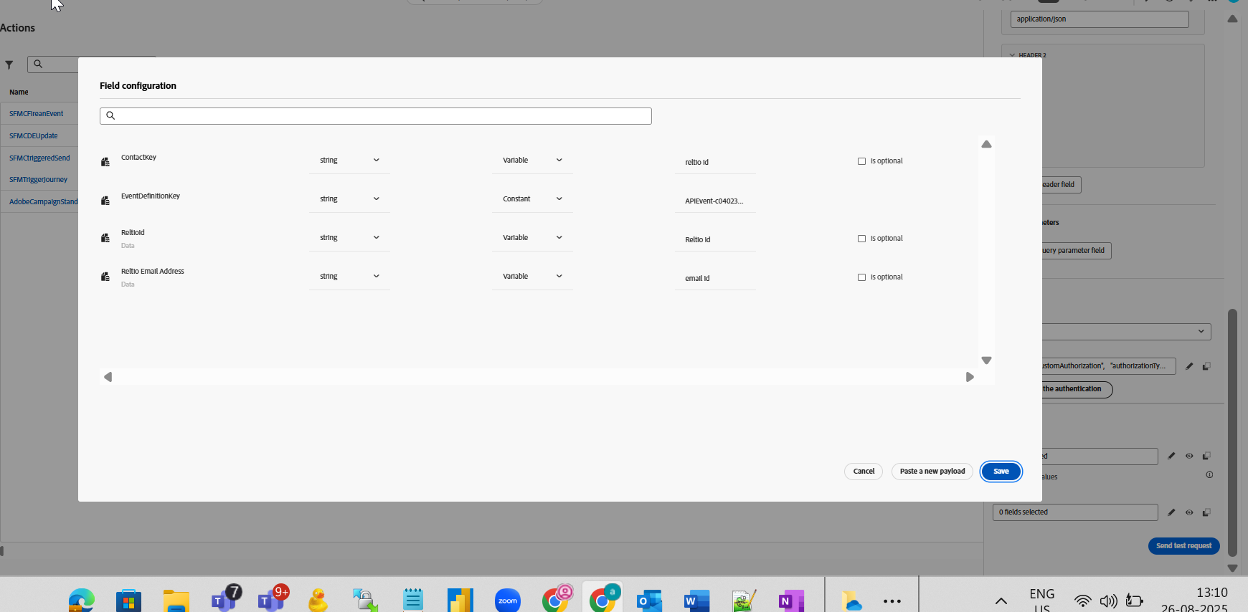

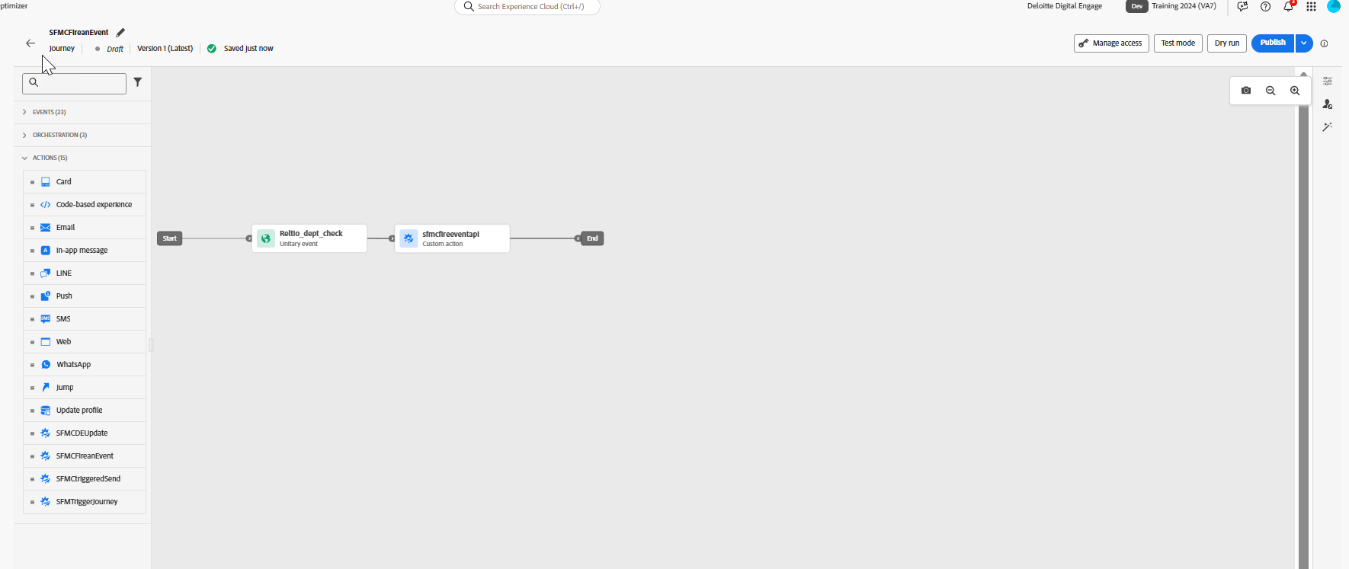

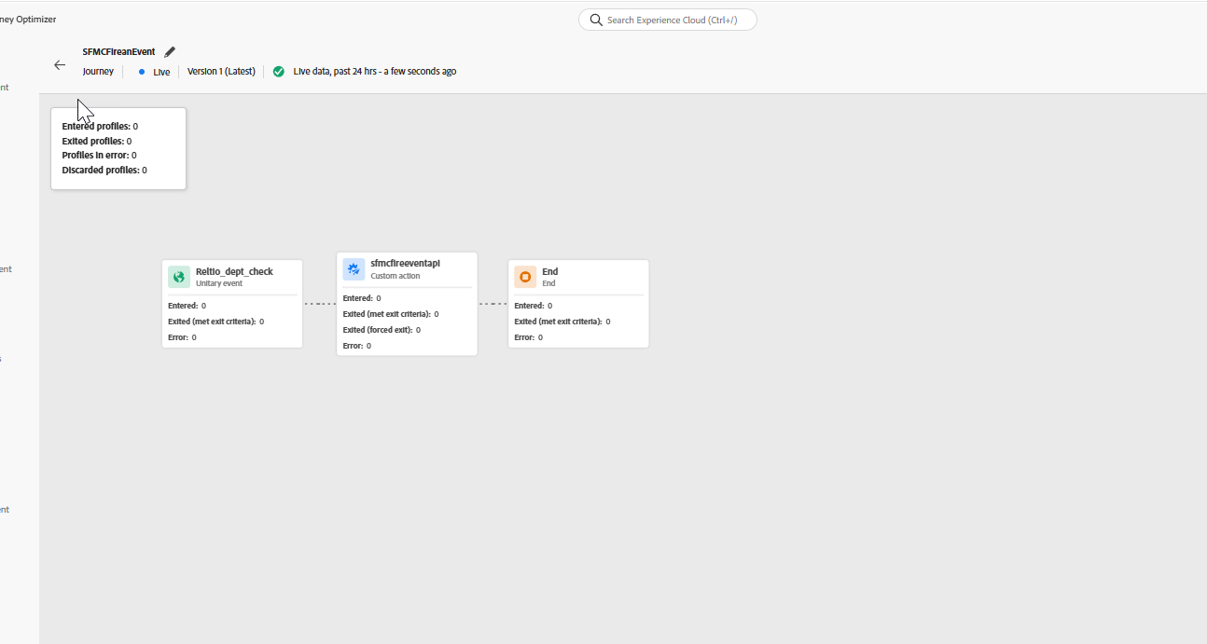
Triggering the reltio_dep_check event in AJO
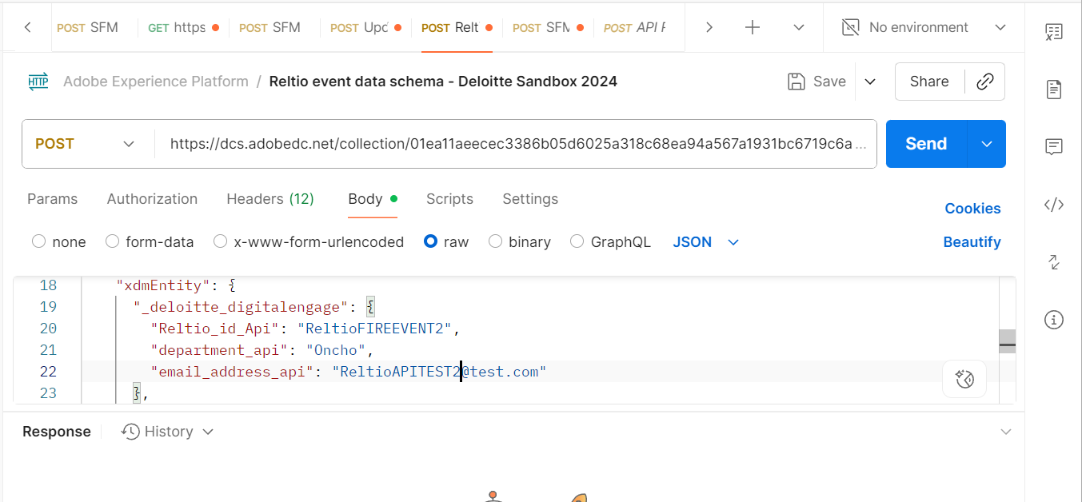

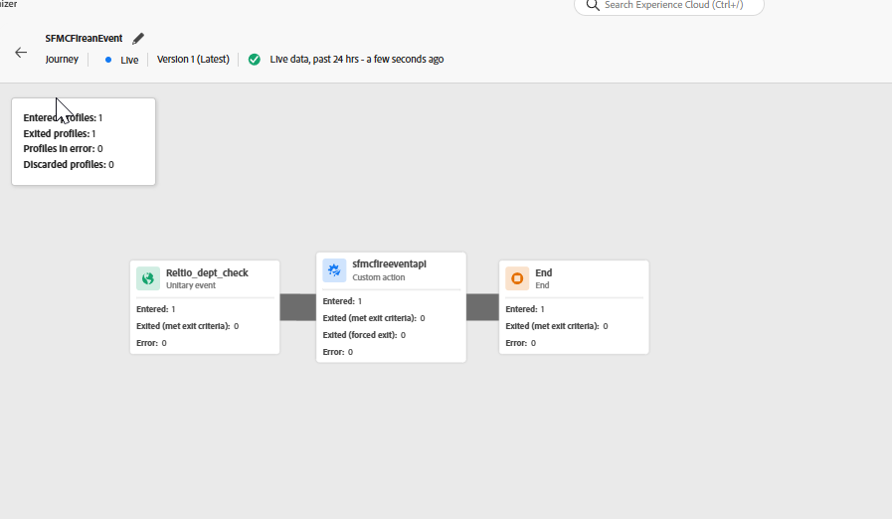

SFMC journey

